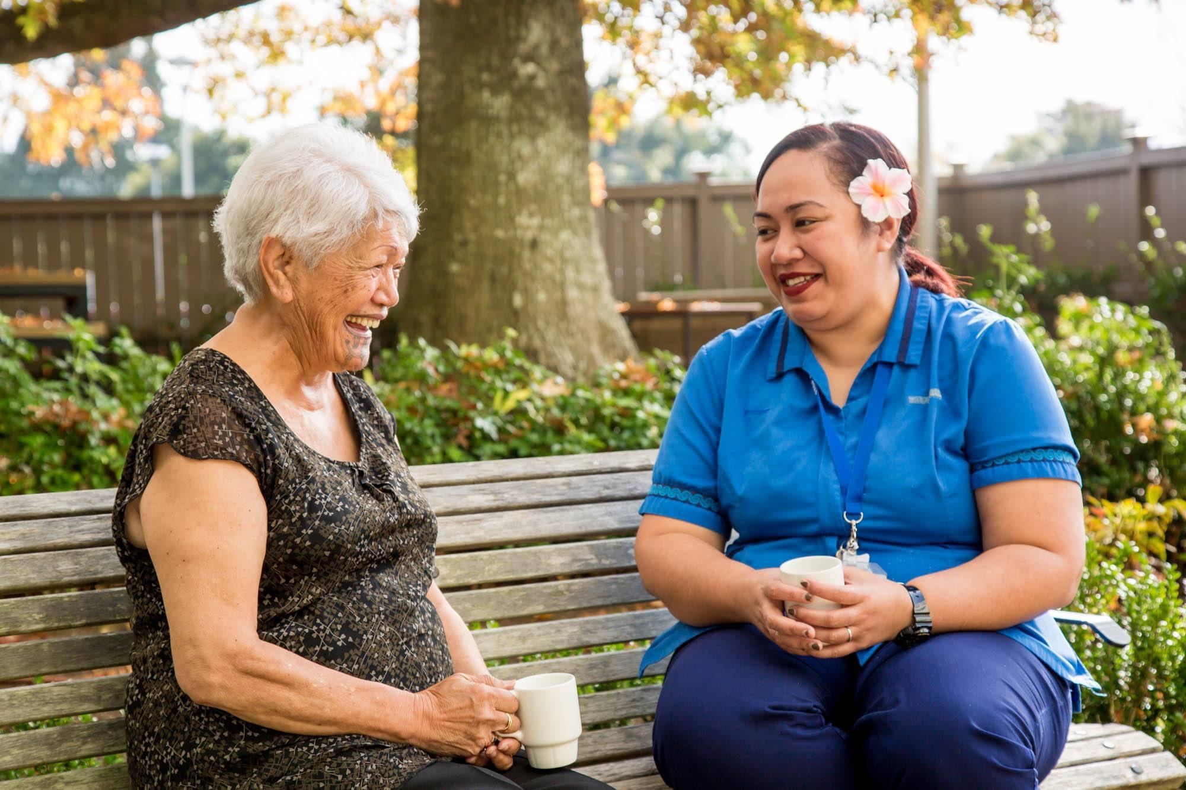

*How to use your eye ointment*

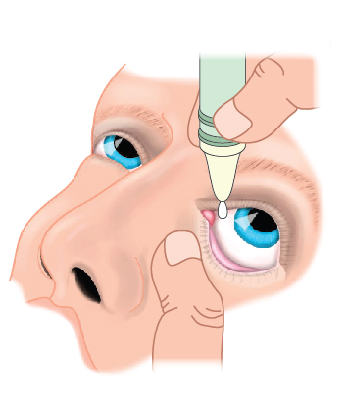

* Wash your hands.
* Read label and check expiry date.
* Remove cap and avoid touching tip of tube.
* Tilt your head slightly and look up.
* Pull down gently on lower lid .
* Hold tube tip directly over the space between the lid and eye.
* Squeeze a thin strip of ointment into the inner part of your lid. Avoid the tube tip from touching the eye.
* Pull up on your upper lid and look down to spread the ointment.
* Close your eye for 30 seconds
* Wipe excess ointment with clean tissue or cloth.
* You may expect blurring of your eye.
* Throw away eye ointment 4 weeks after opening.

*Pterygium Surgery Aftercare Patient Advice*

*For assistance*

* Call Manukau Superclinic™ Module 6 (Ophthalmology) on (09) 277 1660 between 08:00 AM – 04:30 PM
* For afterhours support, call your GP or Greenlane Hospital (09) 367 0000 or go to Green Lane Hospital Acute Eye Service : 214 Green Lane West, Epsom, Auckland

*Patient’s Name: ___________________*

*Operation: Excision of Pterygium with Conjunctival Graft*

*Date: ___________________________*

*Surgeon: _________________________*

*Ophthalmology*

*The maximum size of an image that can fit within this space is 113mm width by 76mm height. Images must good quality and/or high resolution. Send a separate jpeg of your image with this completed, signed off template to the Communications Team to have set up in a print ready version.*

Ophthalmology Department

Module 6 Manukau Superclinic™

901 Great South Road, Manurewa, Auckland

(09) 277 1660

www.countiesmanukau.health.nz



*How to use your eye drops*

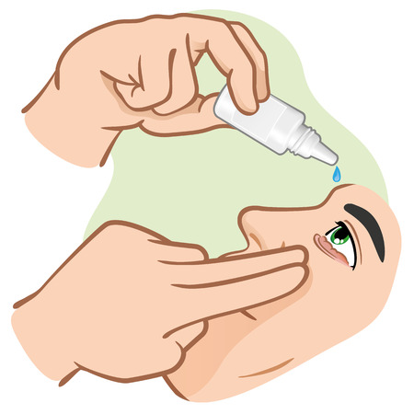

* Wash your hands.
* Read label and check expiry date
* Invert bottle gently
* Remove cap and avoid touching tip of dropper
* Tilt your head slightly and look up
* Pull down gently on lower lid
* Hold dropper tip directly over the space between the lid and eye
* Squeeze one drop into the space between the lid and eye. Avoid the dropper tip from touching the eye.
* Close your eye for 30 seconds.
* Press lightly on the inner corner of your eye to allow drops to be absorbed.
* Wipe excess drops with clean tissue or cloth.
* You may expect blurring of your eye.
* Throw away eye drops 4 weeks after opening.

*What to expect after your surgery*

* You may experience some pain in your eye.
* You may experience scratchy sensation. **Do not** rub your eye.
* You may be sensitive to light in your operated eye. You can wear dark glasses for comfort.
* Your operated eye will be red for about six to 12 weeks, this will settle slowly.

*When to call us*

* Redness or swelling of your eye
* Pain in your operated eye that does not improve with Paracetamol / other prescribed pain relief
* Any bleeding or discharge from your eye
* If you have any questions about your eye drops

*After your surgery*

* An appointment has been made for you in 3-4 weeks; you will receive this letter in the mail.
* You will be seen by the Eye Team
* Remove eye patch 24 hours after surgery

*Medicines after your surgery*

* You will be given a prescription for eye drops / ointment which you must take to your chemist
* Please use the eye drops / ointment as instructed on the label or your prescription
* If your eyes become swollen and painful, stop the eye drops / ointment and contact your GP
* You can use artificial teardrops as often as required for comfort
* For pain relief, take two (2) Paracetamol 500mg tablets every four (4) hours if required. **Do not** take more than 8 tablets a day.