
ARE THERE ANY SIDE EFFECTS?
Side-effects are rare. If it occurs, these are:
- Hiccups or indigestion from the gum and lozenge if not used the proper way. Please refer to instructions inside this brochure.
- Vivid dreams from the patch. If it becomes a problem, remove the patch when sleeping.
- Severe rash from the patch. Use gum or lozenges. Some redness or itching is normal.
- Feeling very light-headed or nauseous, try a lower strength patch, gum or lozenges.
- Still craving, feeling irritable, anxious or restless. Use a higher strength NRT in combination (patch + gum or patch + lozenge.

WHAT IF I SMOKE WITH A PATCH ON?

The aim of using the patch + gum or lozenges is to help you to be smokefree. When you smoke with the use of patch, gum or lozenges, you will feel dizzy and/or nauseous. Remember, smoking will slow down your recovery and healing time.

Stopping smoking is the best thing you can do to look after you and your whānau, and to heal and recover faster.

Nicotine
Replacement
Therapy
Smoking Cessation Tools

If you are a patient or a visitor who would like help to stop smoking and know more about other available options of support and medications, please ask your nurse or doctor.

Auckland Hospital & Greenlane Clinical Centre
Smokefree Service
If you are looking for support or advice on stopping smoking, please get in touch with our service.
One of our practitioners will discuss the best support options for your lifestyle.

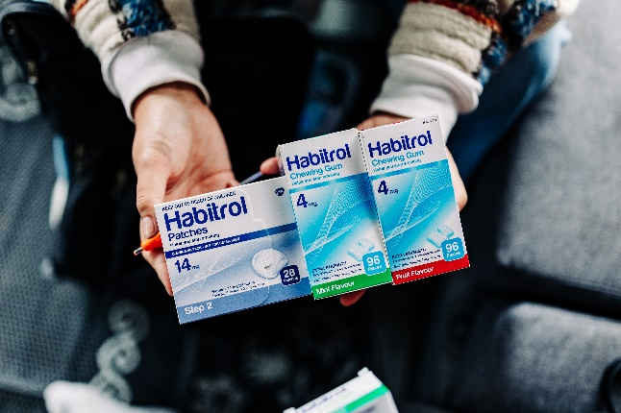
Smokefree Services

0800 667 833
AK-NPHS-Smokefree@tewhatuora.govt.nz

He waka eke noa
We’re all in this together




WHY USE NRT?

Using NRT in combination (Patch + gum or lozenges) for twelve weeks doubles your chances of quitting. NRT helps you to feel more comfortable in situations where you cannot smoke and helps you to remain Smokefree so that you may heal and recover faster.

NRT reduces your urge to smoke by replacing some of the nicotine you get from cigarettes or tobacco without damaging your health.

WHAT DOES IT COST?
NRT is free through the Auckland hospital Smokefree Service as well as many community stop smoking services.
Alternatively, NRT can be accessed from your local pharmacy.

NICOTINE REPLACEMENT THERAPY (NRT) REDUCES ANXIETY, RESTLESSNESS AND THE URGE TO SMOKE. THESE ARE ALL SIGNS THAT A PERSON NEEDS NICOTINE.
USE NRT IN COMBINATION (PATCH + GUM OR PATCH + LOZENGE) FOR AT LEAST THREE MONTHS.
GUM (4mg or 2mg) or LOZENGE (2mg or 1mg)
Provides a burst of nicotine when needed. Takes 20-30 minutes to start working.
- It is important not to use gum like regular chewing gum.
- Do not bite down on the lozenge.
- Chew gum/suck lozenge until you get a ‘peppery’ taste, then rest it between your cheek and gums. Repeat this process every few minutes for 20-30 mins, then remove. Use up to 15 pieces a day.

NRT IS SAFER THAN SMOKING
Haere Mai Welcome Manaaki Respect Tūhono Together Angamua Aim High
IS NRT SAFE?
Yes. It only contains nicotine in small amounts, making it safe and not addictive. It is the tar and carbon monoxide in cigarettes that is bad for you.
CAN ANYONE USE NRT?
Anyone over 12 years old who smokes can use NRT.
If you need to use NRT and you are:
- Pregnant - try nicotine gum or lozenges first. If these do not help you, use nicotine patch with gum or lozenges but take the patch off when you sleep.
- Recovering from a recent heart attack or unstable angina - try nicotine gum or lozenges first. If these do not help you, use nicotine patch with gum or lozenges.
- Having surgery where you have been told that nicotine may slow wound healing - try nicotine gum or lozenges first. if these do not help, use nicotine patch with gum or lozenges.

When stopping smoking, the doctor may need to adjust the dose of some medications including: clozapine, olanzapine, warfarin, fluvoxamine, haloperidol, theophylline and chlorpromazine.

PATCH, GUM OR LOZENGE
PATCH (21mg, 14mg and 7mg)
Provides a slow constant release of nicotine.
Takes two to three hours to start working. How to use:
- Put the patch on a clean hairless part of the skin.
- Replace patch after 24 hours, putting the new patch on a new area of skin.

