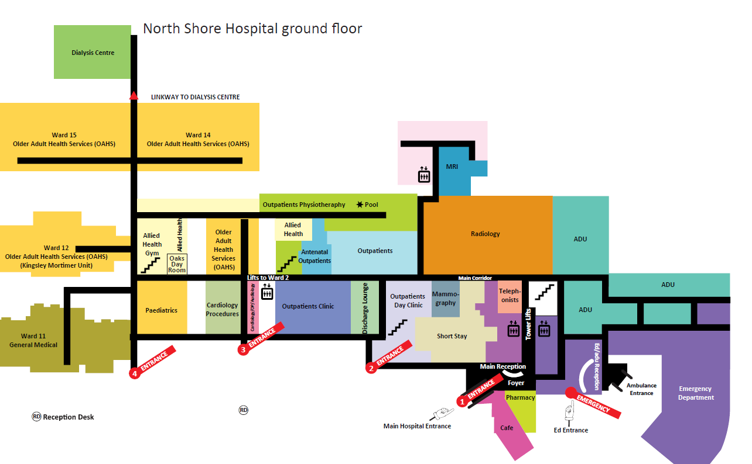

**Entrance 2 or 3**

Outpatient Reception 1 Outpatient Reception 3

Orthopaedic Reception 4

Orthopaedic Reception 4

Outpatient Reception 1

Outpatient Reception 3